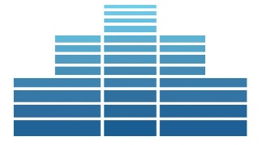 | Preparing for National Community Development Week  A Checklist

Gather Data

Gather details on grants received

Create database of stories

Gather the Troops

Identify & Engage Community Partners

Decide What to Highlight

Which projects best make your point about the value of the programs?

Which projects have generated local support (both financial and personal)?

Which projects will your specific policymakers be most interested in?

Learn about Policymakers

Who represents the area?

What are their political views?

What policy issues interest them?

Work the Timeline
National Community Development Week occurs during Congressional Easter Recess

Begin preparations three to four months out (December/January timeframe)

Have requests to legislators in by six weeks ahead of event
Preparing for National Community Development Week
A Checklist: Engaging Legislators

Write a Letter & Fact Sheet

See sample letter from Durham, North Carolina

See fact sheet template

Issue a Proclamation

See sample proclamation from Columbus, Georgia

Meet with Members of Congress and/or Staff in Local Offices

Find local addresses and phone numbers & check schedule on house.gov and senate.gov

See sample meeting request (customize for your situation!)

Set up a Site Visit

See sample site visit invite

See site visit checklist
Hold a Ground-Breaking or Ribbon Cutting Ceremony

…And More!

Op-Ed (see Inland Daily Bulletin Sample)

Local Newspaper Story (see Portland Maine sample)

Congressional Record Statement (see template)

